AWS Task-3

- Create a S3 bucket, with no public access and upload files to the bucket.

Created the bucket name rakesh-bucket
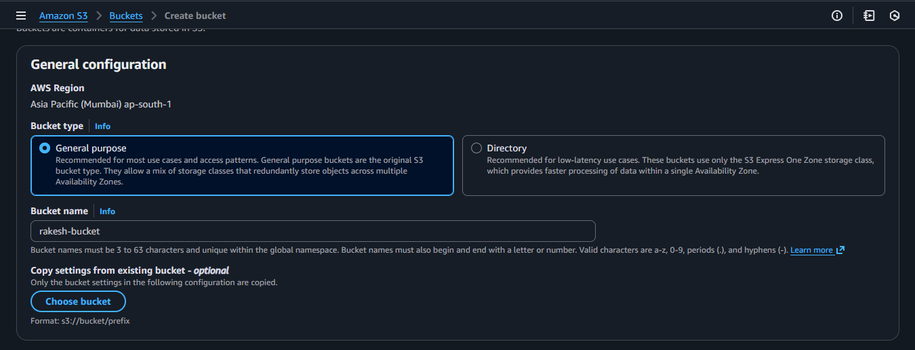
Blocked all the public access while creating.
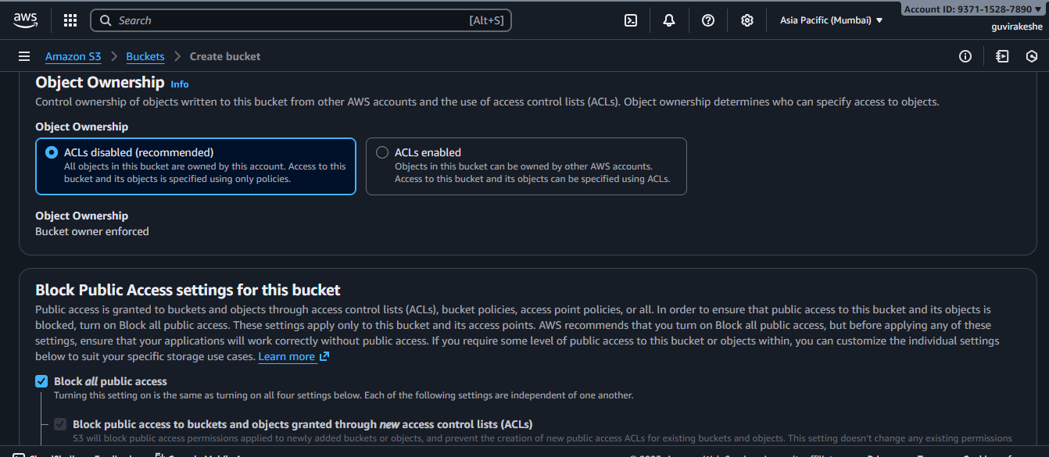
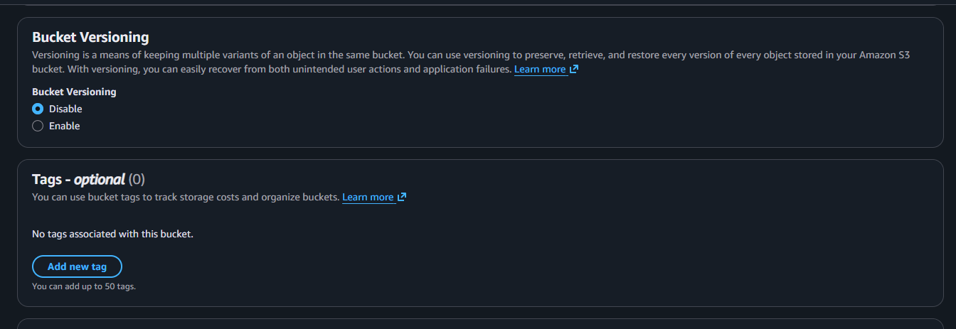

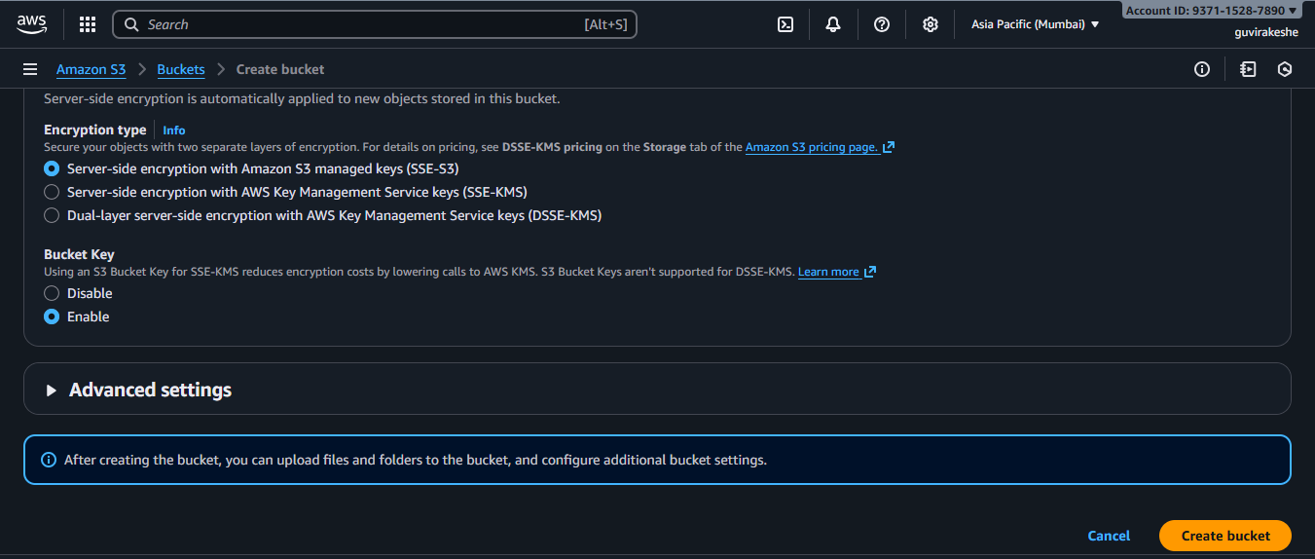
S3 Bucket created
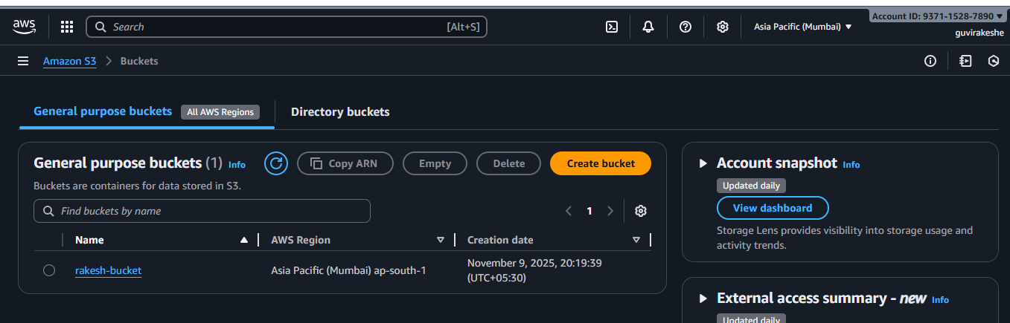
Uploaded the file in s3: rakesh-bucket
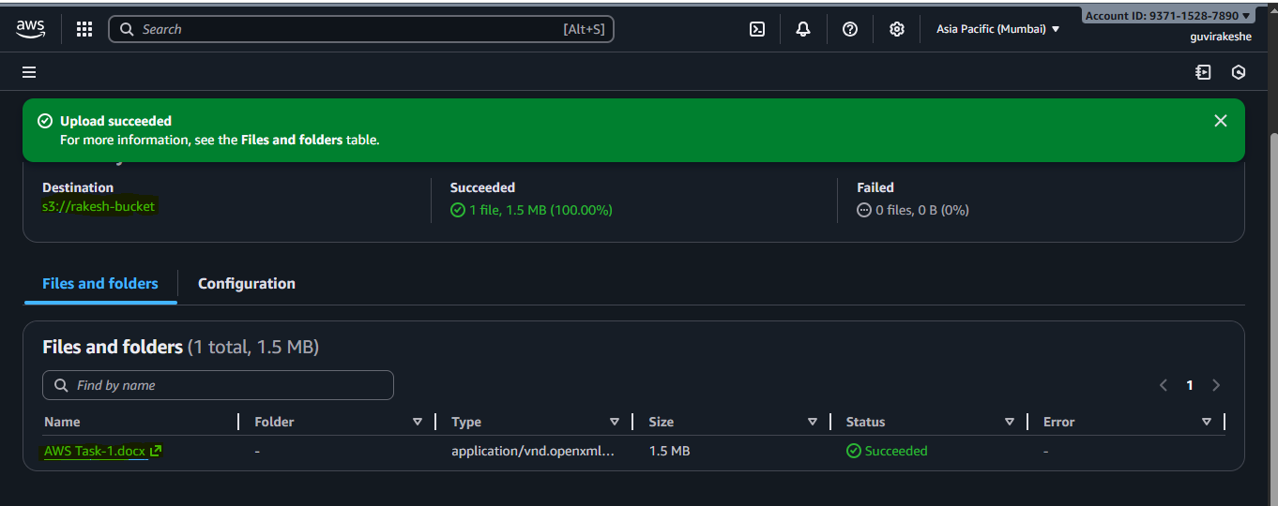

- Launch two ec2-instances and connect it to a application load balancer, where the output traffic from the server must be an load balancer IP address
Create the 1st EC2 instance.
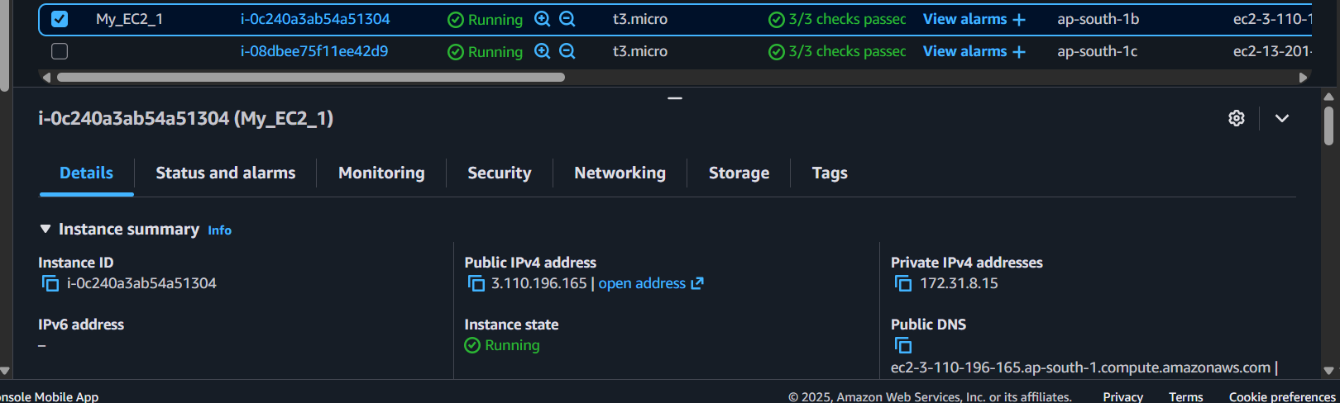

Inbound Rules
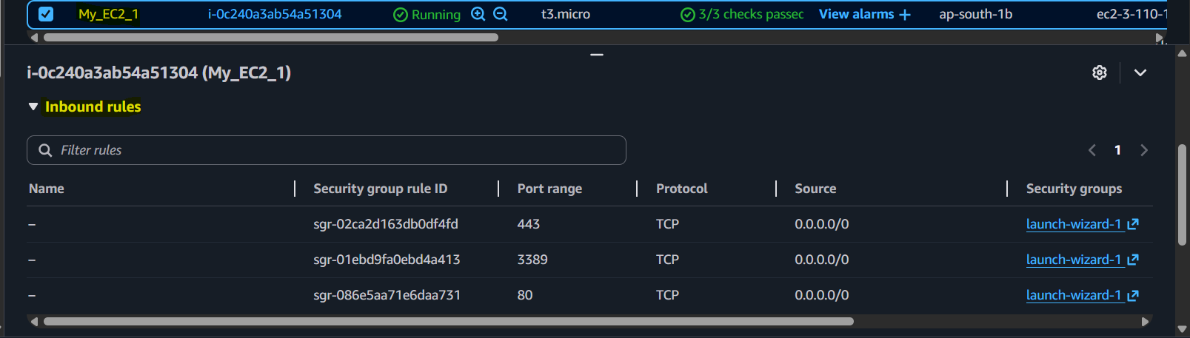
No outbound rules specified
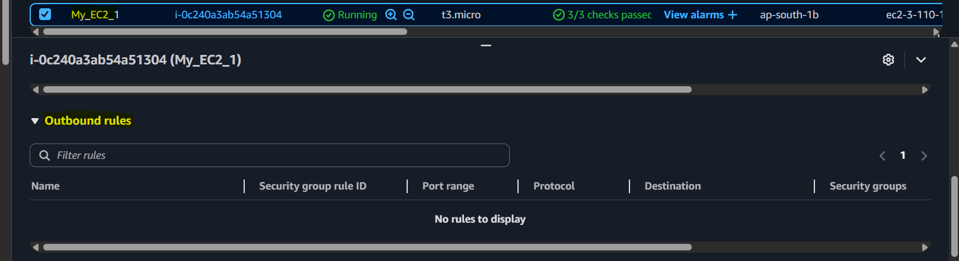

Created the 2nd EC2 instance.
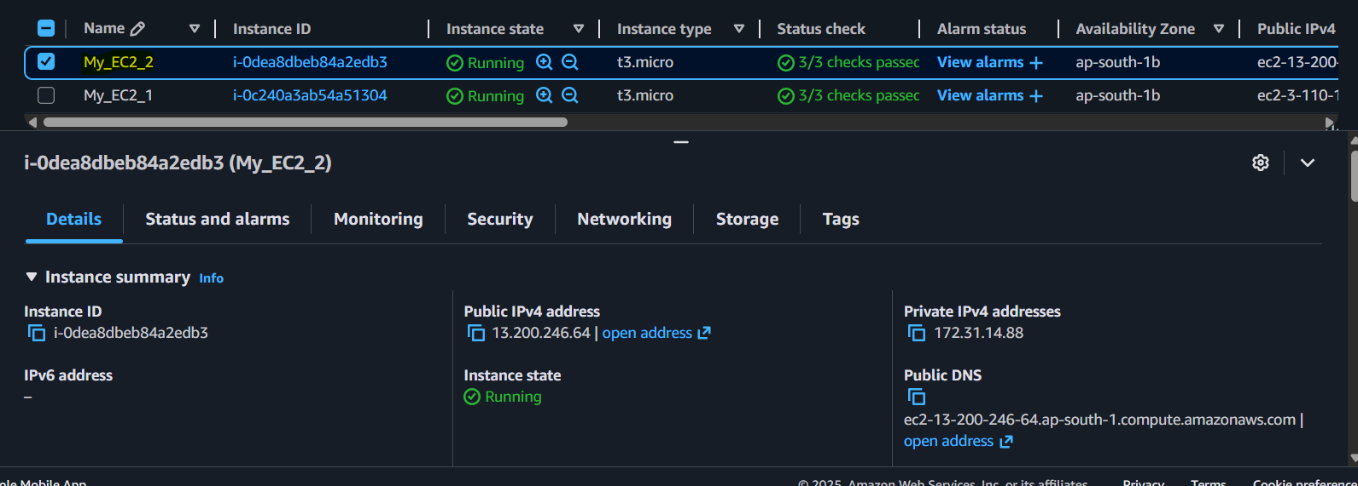
Inbound Rules
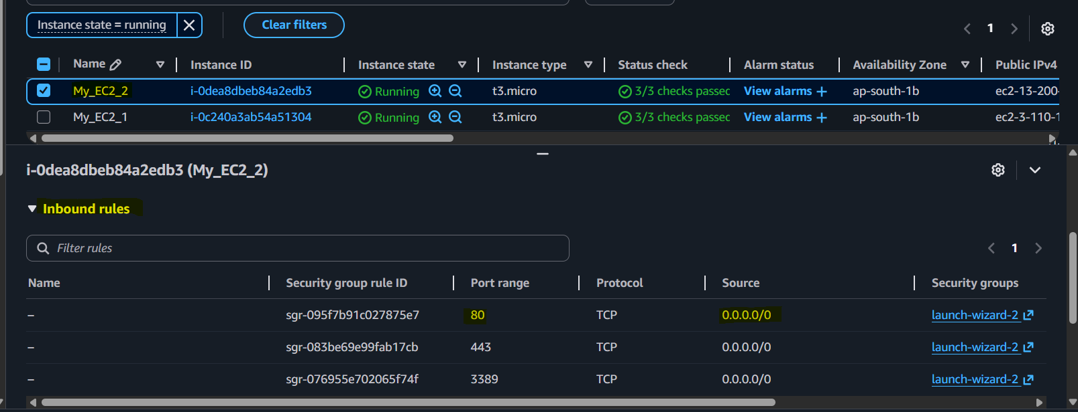
No outbound rules specified
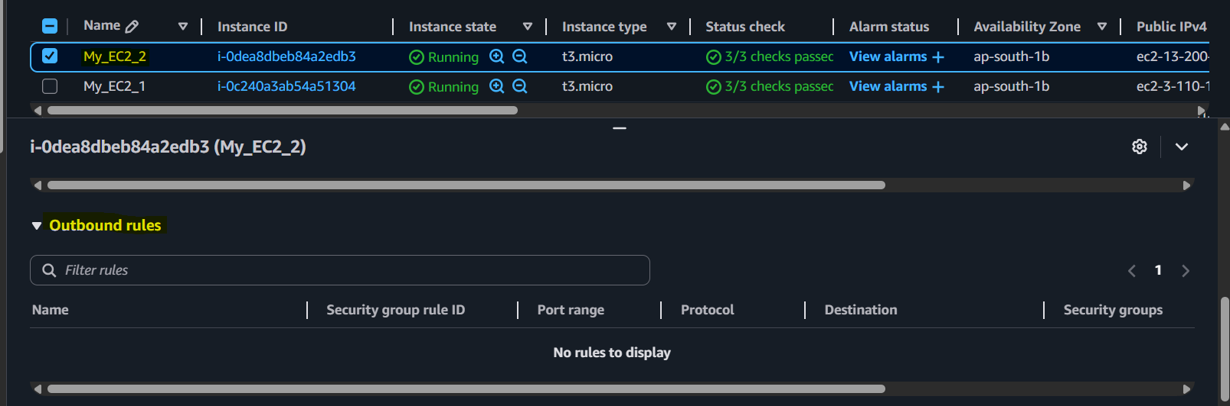

Created the Application load balancer.
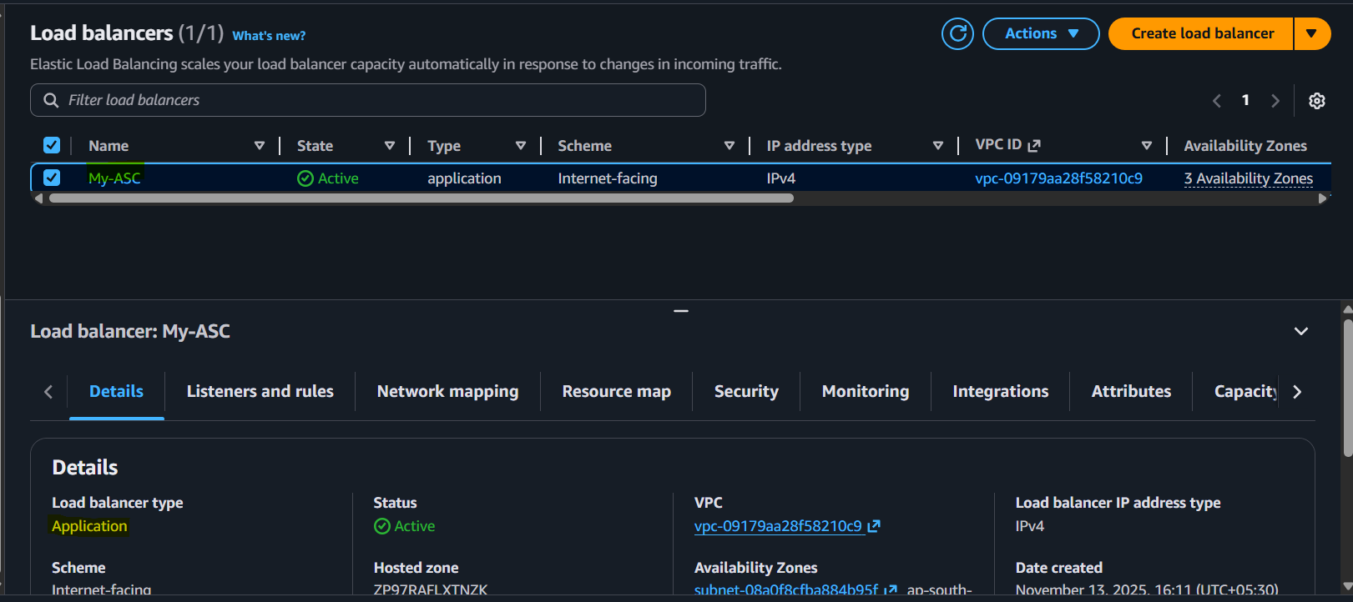
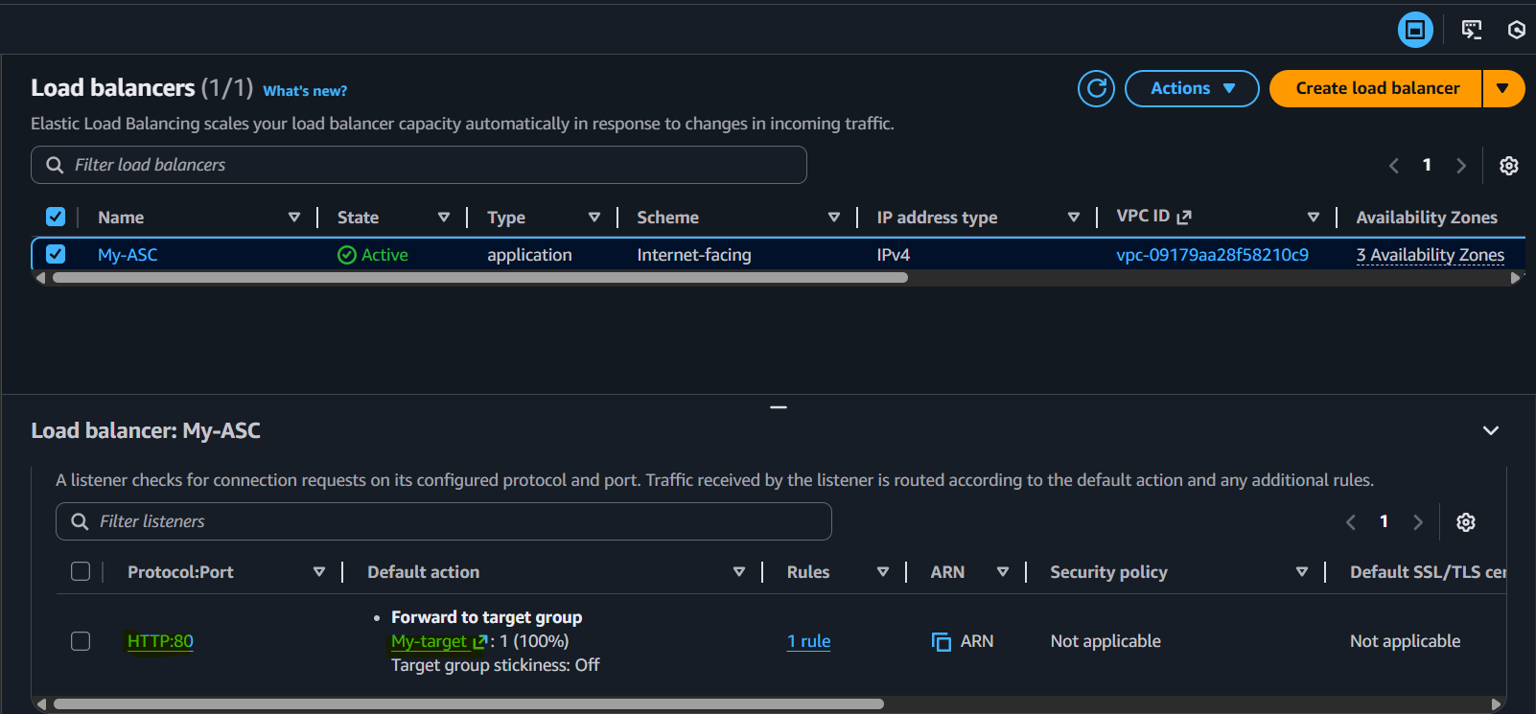
Load balancer security group.
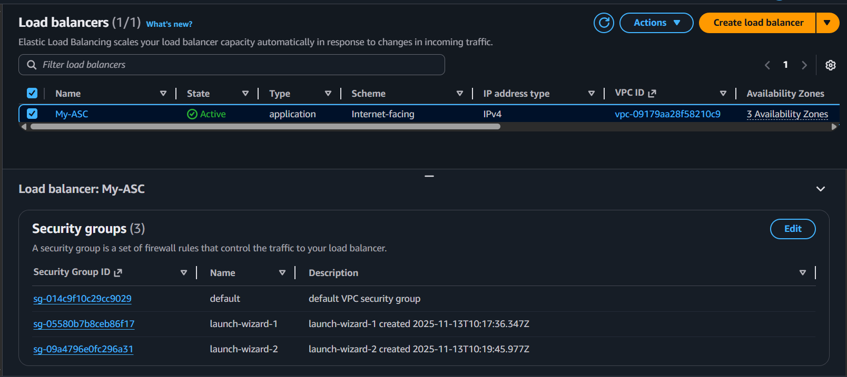

Load balancer security group outbound rules as public.
